Case Study - Product Aarthi. P
db.createCollection("Product")
db.Product.insertMany(
[
{
"id": "1",
"product_name": "Intelligent Fresh Chips",
"product_price": 655.00,
"product_material": "Concrete",
"product_color": "mint green"
},
{
"id": "2",
"product_name": "Practical Fresh Sausages",
"product_price": 911.0,
"product_material": "Cotton",
"product_color": "indigo"
},
{
"id": "3",
"product_name": "Refined Steel Car",
"product_price": 690.00,
"product_material": "Rubber",
"product_color": "gold"
},
{
"id": "4",
"product_name": "Gorgeous Plastic Pants",
"product_price": 492.00,
"product_material": "Soft",
"product_color": "plum"
},
{
"id": "5",
"product_name": "Sleek Cotton Chair",
"product_price": 33.00,
"product_material": "Fresh",
"product_color": "black"
},
{
"id": "6",
"product_name": "Awesome Wooden Towels",
"product_price": 474.00,
"product_material": "Plastic",
"product_color": "orange"
},
{
"id": "7",
"product_name": "Practical Soft Shoes",
"product_price": 500.00,
"product_material": "Rubber",
"product_color": "pink"
},
{
"id": "8",
"product_name": "Incredible Steel Hat",
"product_price": 78.00,
"product_material": "Rubber",
"product_color": "violet"
},
{
"id": "9",
"product_name": "Awesome Wooden Ball",
"product_price": 28.00,
"product_material": "Soft",
"product_color": "azure"
},
{
"id": "10",
"product_name": "Generic Wooden Pizza",
"product_price": 84.00,
"product_material": "Frozen",
"product_color": "indigo"
},
{
"id": "11",
"product_name": "Unbranded Wooden Cheese",
"product_price":26.00,
"product_material": "Soft",
"product_color": "black"
},
{
"id": "12",
"product_name": "Unbranded Plastic Salad",
"product_price": 89.00,
"product_material": "Wooden",
"product_color": "pink"
},
{
"id": "13",
"product_name": "Gorgeous Cotton Keyboard",
"product_price": 37.00,
"product_material": "Concrete",
"product_color": "sky blue"
},
{
"id": "14",
"product_name": "Incredible Steel Shirt",
"product_price": 54.00,
"product_material": "Metal",
"product_color": "white"
},
{
"id": "15",
"product_name": "Ergonomic Cotton Hat",
"product_price": 43.00,
"product_material": "Rubber",
"product_color": "mint green"
},
{
"id": "16",
"product_name": "Small Soft Chair",
"product_price": 47.00,
"product_material": "Cotton",
"product_color": "teal"
},
{
"id": "17",
"product_name": "Incredible Metal Car",
"product_price":36.00,
"product_material": "Fresh",
"product_color": "indigo"
},
{
"id": "18",
"product_name": "Licensed Plastic Bacon",
"product_price":88.00,
"product_material": "Steel",
"product_color": "yellow"
},
{
"id": "19",
"product_name": "Intelligent Cotton Chips",
"product_price": 46.00,
"product_material": "Soft",
"product_color": "azure"
},
{
"id": "20",
"product_name": "Handcrafted Wooden Bacon",
"product_price": 36.00,
"product_material": "Concrete",
"product_color": "lime"
},
{
"id": "21",
"product_name": "Unbranded Granite Chicken",
"product_price": 90.00,
"product_material": "Metal",
"product_color": "gold"
},
{
"id": "22",
"product_name": "Ergonomic Soft Hat",
"product_price": 99.00,
"product_material": "Rubber",
"product_color": "black"
},
{
"id": "23",
"product_name": "Intelligent Steel Pizza",
"product_price": 95.00,
"product_material": "Cotton",
"product_color": "azure"
},
{
"id": "24",
"product_name": "Tasty Rubber Cheese",
"product_price":47.00,
"product_material": "Frozen",
"product_color": "orchid"
},
{
"id": "25",
"product_name": "Licensed Steel Car",
"product_price":20.00,
"product_material": "Cotton",
"product_color": "indigo"
}
])

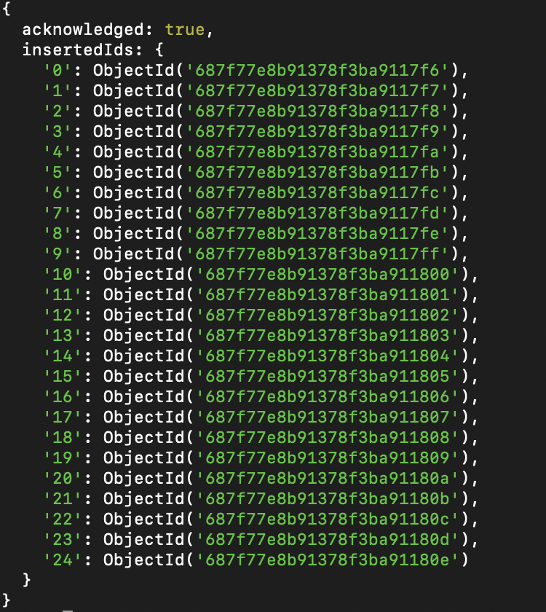

- Find all the information about each products

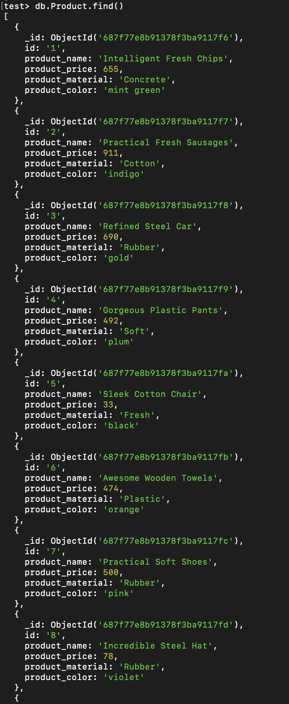

- Find the product price which are between 400 to 800

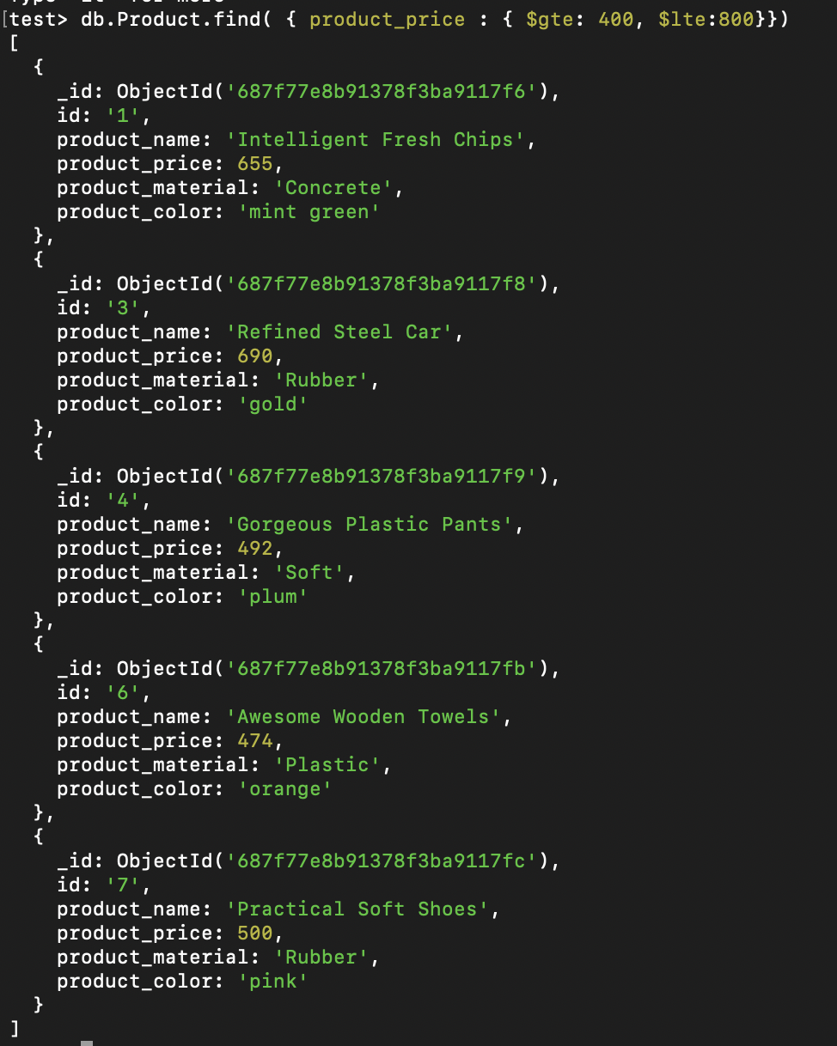

- Find the product price which are not between 400 to 600

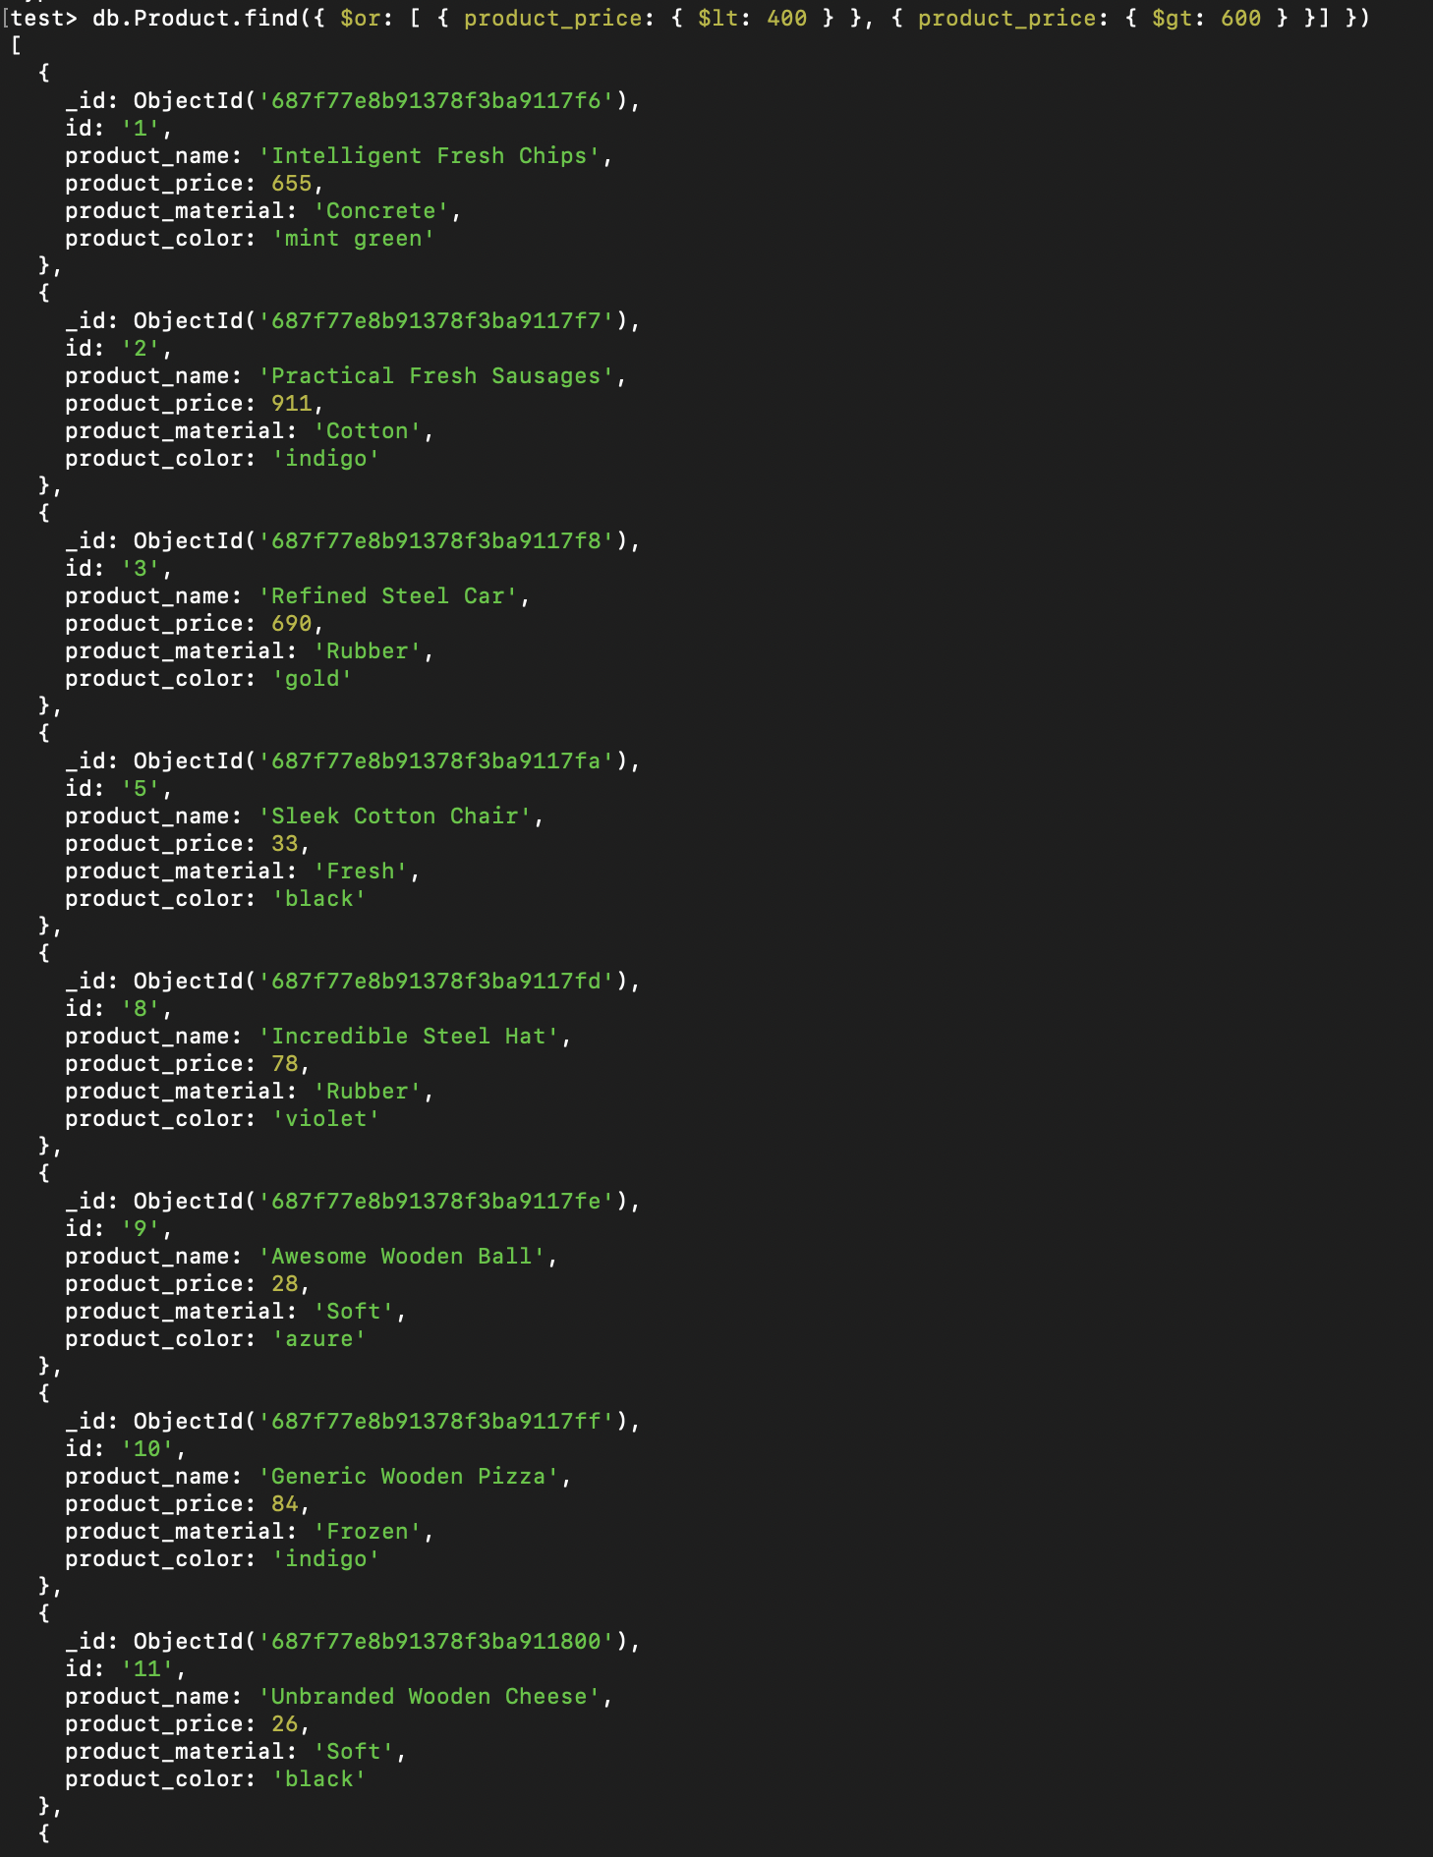

- List the four product which are grater than 500 in price

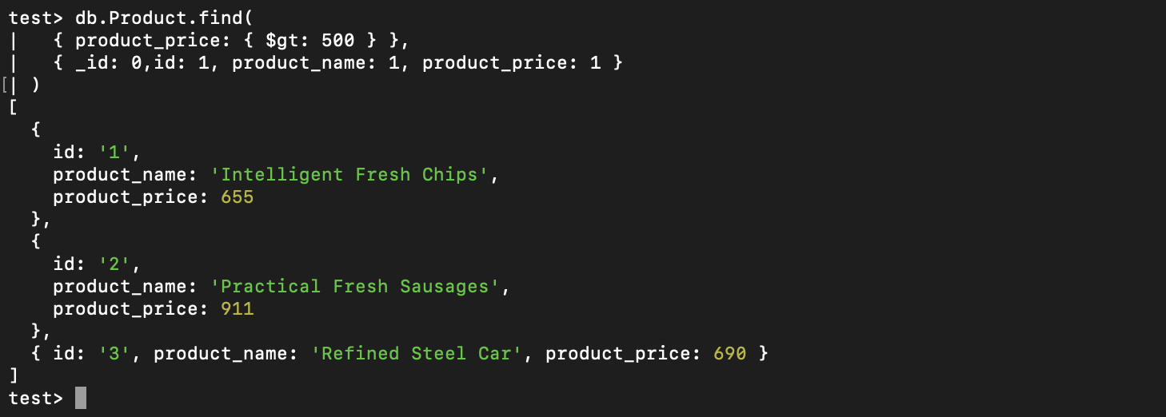

- Find the product with a row id of 10

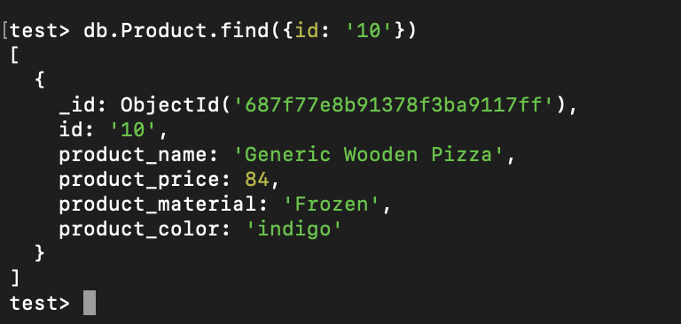

- Find the product name and product material of each products

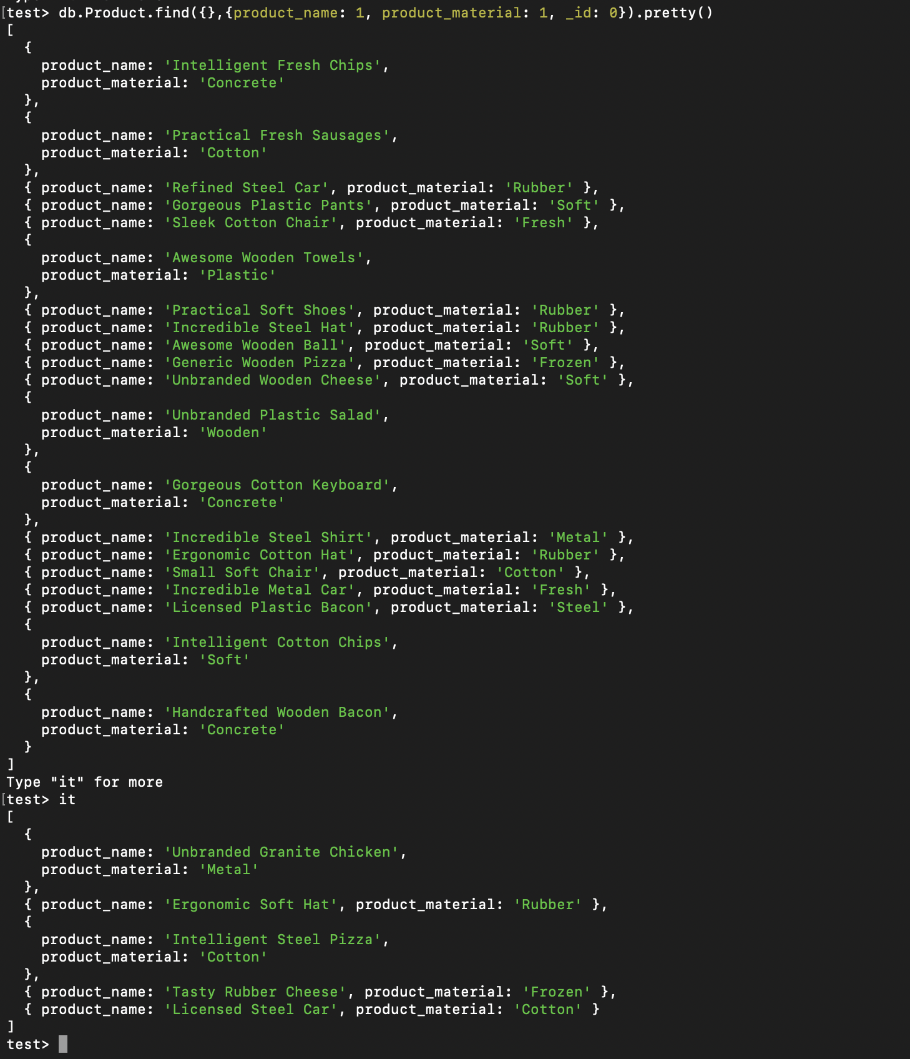
- Find all products which contain the value of soft in product material

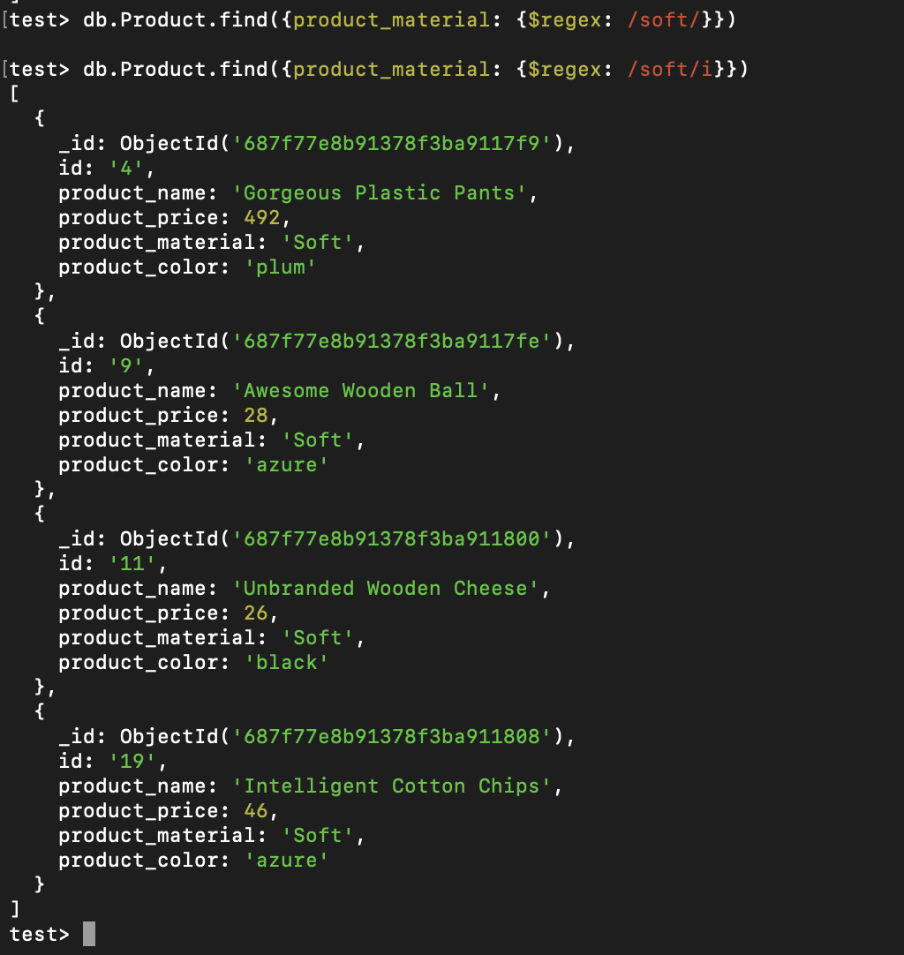

- Find products which contain product color indigo and product price 492.00

